# ML Coursework Tutorial 9 Question 3

Jqk17

1. Numerical values for voltages (V):

﻿[[3.1953851 1.91437537]

[7.19831173 7.70619219]

[2.88389115 6.3965953 ]]

1. Random forest classifier

1. Nearest neighbour approach

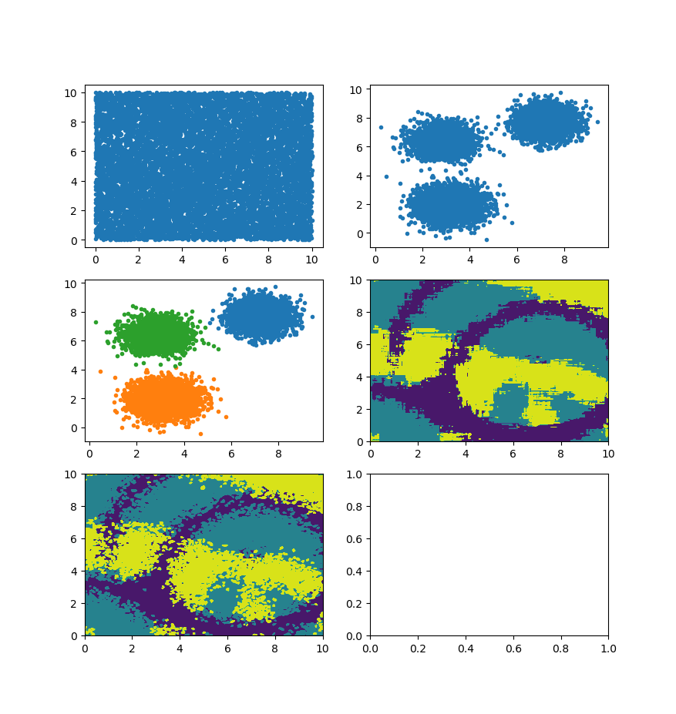

1. Review:
   1. Random forest classifier, less “pixelated” or “jagged” boundaries as compared to nearest neighbour approach
   2. Using regression; yes you can use regression classifiers (i.e., logistic regression)